DSL Assignment 05 : Testcases. (Roll Number: **21118**)

Testcase1 : (Insertion sort -> no duplicates)

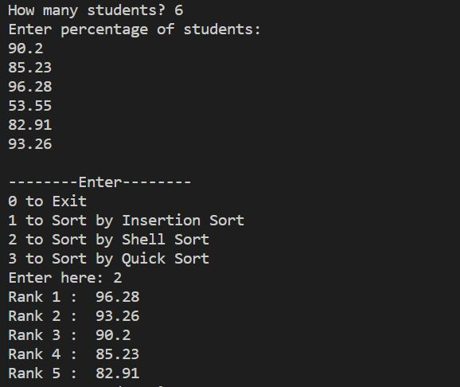

Testcase2: (Shell sort -> no duplicates)

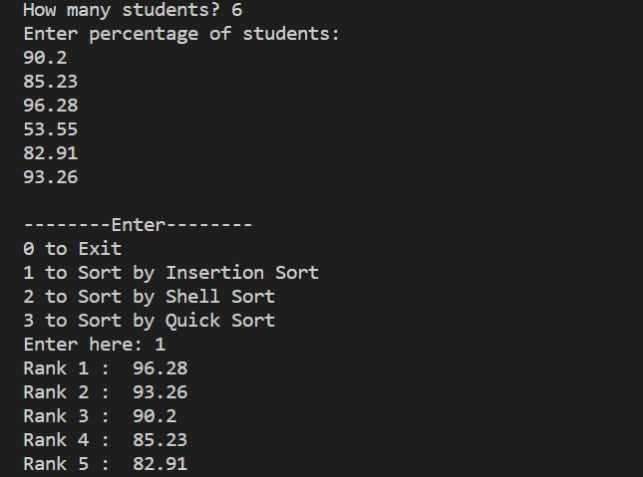

Testcase3: (Insertion sort -> duplicates)

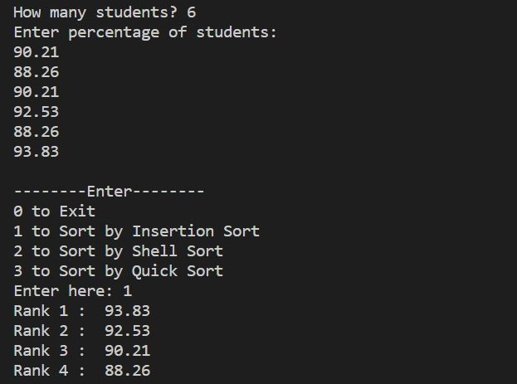

Testcase4: (Shell sort -> duplicates present)

